Instructions for the preparation of the Title paper in MS Word (January 2024)

First A. Author1, Second B. Author2, and Third C. Author3

1College of Science, Department of Computer Science, University of Diyala, Bequeath, 23001 IRAQ

2College of Engineering, Department of Communication, University of Diyala, Bequeath, 23001 IRAQ

2College of Engineering, Department of Electronics, University of Diyala, Bequeath, 23001 IRAQ

Corresponding author: First A. Author (e-mail: author@ Uodiyala.edu.iq).

ABSTRACT: A professionally designed abstract allows readers to quickly and accurately understand the main content of the document, assess its relevance to their interests, and decide whether or not to read the full text. It is important that the abstract contains clear and concise information to highlight the research problem, the proposed solution or approach, the main results, and the conclusions. The content of the abstract should be 150 to 250 words and written in the past tense. Abbreviations and the use of standard terms should be avoided. Literature citations are not permitted. A keyword list is essential to include keywords, which can help indexing services and improve the article’s visibility to interested readers**.**

KEYWORDS: Keyword1, Keyword2, Keyword3, Keyword4, Keyword5

1. INTRODUCTION

This document serves as a template for Microsoft Word versions. If you are viewing a printed or PDF version, please download the Word template from the DJAI Page Author Center at the provided link (MS Word Template).

II. PREPARING the MANUSCRIPT

To insert images in a document of Word, place the cursor at the desired location and either select Insert (Picture - From File or copy the image to the Windows clipboard and use Edit - Paste Special Picture to ensure "float over text" is unchecked).

1. ACRONYMS AND ABBREVIATIONS

Select abbreviations and acronyms the first time they appear in the text, even if they were already defined in the abstract. Common abbreviations like DJAI, SI, ac, and dc do not require definition. The abbreviations which included, omit spaces (e.g., write "C.N.R.S." instead of "C. N. R. S."). Avoid using abbreviations in the title unless necessary [1].

1. OTHER RECOMMENDATIONS

Use hyphens within single spaces after periods and dots when writing your essay. Avoid using the suspended present tense; for example, instead of writing "Using (1), the features were calculated", clarify the subject by stating "The features were calculated using (1)." To edit the text, type directly into the sections of the MS .docx file or copy and paste the content from another document, applying the markup styles. In the Styles menu, on the Formatting toolbar, styles are selected; for example, the current style is "Text". Highlight the appropriate style name from the list, which provides the ability to adjust fonts and line spacing automatically. It is important that font sizes or line spacing do not change to fit the content on limited pages. Avoid using italics and underlining .

METHODLOGY

When writing equations using MS Word, you should use the Equation Editor or by using the MathType add-in (http://www.mathtype.com) for equations in the text should follow the steps (Insert - Object - Create New - Microsoft Equation or MathType Equation). In addition, avoid selecting Float over text.

E = mc2 (1)

To ensure that symbols in equations are displayed correctly, they should appear immediately before or after the equation. Symbols should be written in italics. Refer to "(1)", not "Equation (1)" or "Equation (1)", except at the beginning of the sentence: "Equation (1) is...".

SOME COMMON MISTAKES

Explaining the content of the paper chronologically, which usually includes the research design, research procedures (through writing algorithms, pseudo-code, etc.), and the stages of conducting tests until obtaining the results [2], [3]. The paper should include a clear description of the study process supported by references to ensure the reliability of the study from the scientific aspect [4], [5], [6]. Tables and figures are displayed in the middle as shown in Table 1 and Figure 1.

TABLE I

Performance of the neural network

|  |  |  |  |  |  |
| --- | --- | --- | --- | --- | --- |
| Model | MSE | RMSE | R (Training) | R2 | Rank |
| ENN | 5371.5 | 84.67 | 0.67 | 0.67 | 3 |
| CFNN | 7440.5 | 80.78 | 0.78 | 0.81 | 2 |
| LRNN | 9583.7 | 67.89 | 0.89 | 0.86 | 1 |
| NARX | 4804.6 | 71.40 | 0.79 | 0.87 | 4 |

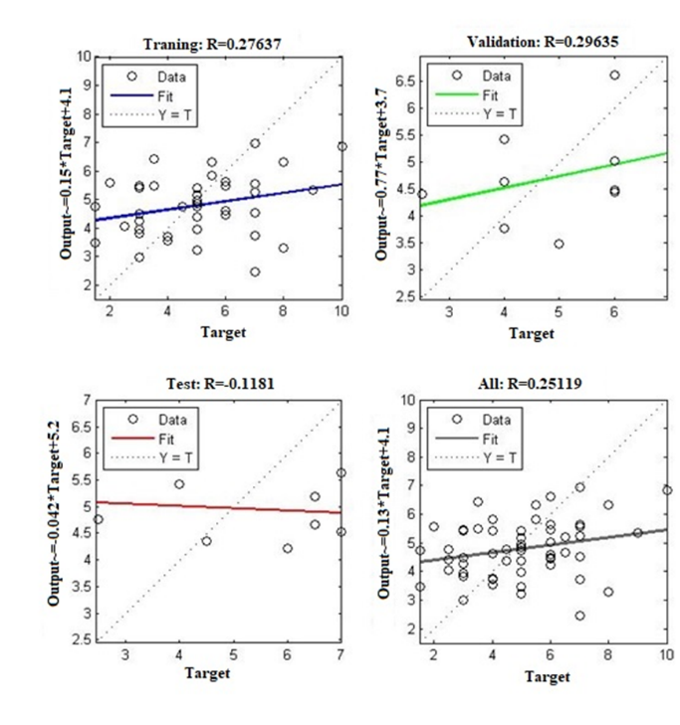

1. correlation coefficient of predictor values
2. GUIDELINES FOR FIGURES AND TABLES SETUP
3. TYPES OF GRAPHICS

Acceptable figures and graphics in DJAI, which are categorized by their construction and use of color or grayscale:

1) FIGURES (COLOR OR GRAYSCALE)

Figures that appear in color or black/grayscale. These figures often include photographs, multicolor graphs, and flowcharts.

2) TABLES

Data tables should be in black and white and sometimes include color.

3) LINE ART

Figures that consist of black lines and shapes only. These figures are usually in black and white only and should not contain shadows or semi-grayscale.

4) AUTHOR PORTRAITS

Head and shoulder shots of authors that appear at the end of our papers with a biographical summary.

1. CONCLUSION

A conclusion section is not required. Although a conclusion may review the main points of the paper, do not replicate the abstract as the conclusion. A conclusion might elaborate on the importance of the work or suggest applications and extensions.

ACKNOWLEDGMENT

The preferred word for "acknowledgment" in American English is without the "e" after the "g". As well as, avoid expressions such as “One of us (Q.M.Y.) would like to thank . . . .” Instead, write “M. A. Author thanks . . . .” often, sponsor and financial support acknowledgments are placed in the unnumbered footnote on the first page, not here.

REFERENCES

[1] G. K. Yas, Q. M., & Ouda, “Toward on Develop a Framework for Diagnosing Novel-COVID-19 Symptoms Using Decision Support Methods,” in *In International Conference on Emerging Technology Trends in Internet of Things and Computing*, 2021, pp. 93–107.

[2] K. G. Yas, Q.M., Ibrahim, D.S. and Mohammed, “Academic Ranking of Diyala University Using Hybrid Decision-Making Approach,” in *In AIP Conference Proceedings*, 2023, pp. 1–13.

[3] Q. M. Yas, A. A. Zadain, B. B. Zaidan, M. B. Lakulu, and B. Rahmatullah, “Towards on develop a framework for the evaluation and benchmarking of skin detectors based on artificial intelligent models using multi-criteria decision-making techniques,” *Int. J. Pattern Recognit. Artif. Intell.*, vol. 31, no. 3, 2017, doi: 10.1142/S0218001417590029.

[4] and S. H. A. A. K. Jassim Al-Shamary, Q. M. Yas, A. M. Badr, R. Al Shalabi, “Multi Criteria Decision Making Technique for Evaluation and Selection performance Large Scale Data of Composite Materials,” in *in 2022 ASU International Conference in Emerging Technologies for Sustainability and Intelligent Systems, ICETSIS*, 2022, pp. 96–103.

[5] Q. M. Yas and F. K. Zaidan, “A NEW HYBRID MULTI-CRITERIA DECISION APPROACH FOR EVALUATING AND BENCHMARKING VACCINES,” *Int. J. Tech. Phys. Probl. Eng.*, vol. 15, no. 54, pp. 33–38, 2023.

[6] Q. M. Yas and Y. K. Hameed, “Rainfall rate prediction using recurrent neural network with long short-term memory algorithm: Iraq case study,” *Int. J. Comput. Appl. Technol.*, vol. 74, no. 1–2, pp. 125–135, 2024, doi: 10.1504/IJCAT.2024.141352.

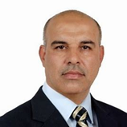**First A. author**: Qahtan Majeed Yas Birthday: 30/07/1966. Birth Place: Baqubah, Iraq. Bachelor: Computer Science Department, Faculty of Computer Science, University of Diyala, Diyala,

Iraq, 2007 Master: Artificial Intelligent, Faculty of Information Technology, National Energy University, Selangor, Malaysia, 2013 Doctorate: Artificial Intelligent, Faculty of Art, Computing and Creative Industry, University of Pendidikan Sultan Idris, Tanjung Malim, Malaysia, 2018. Research Interests: Application of Artificial Intelligence, Multi-Criteria Decision Making, Fuzzy systems, Scientific Publications: 32 Papers.